***Crypton CNG Management System***

***(Project Report)***

***Contributors***

1. Fariha Tasnim Samsi
2. Md. Shahadul Alam Patwary
3. Sabrina Islam
4. Tahsan Dewan

***Contents***

1. Executive Summary
2. Features
3. ER-diagram
4. Schema-diagram
5. User Manual
6. Codes/Query

***Executive Summary***

CNG management system will help people to lessen their transportation problem. If a person is in hurry, he/she can’t find proper transport. As a result, he/she can’t reach his/her destination in time. There are many roads where vehicles like rickshaws are not allowed. For this, middle class people have to suffer and they can’t find proper transportation. CNG management system will help people in these matters and lessen their sufferings. If a passenger is worried about late night party how he/she will return home then there is a solution for that problem in our system. People can do advance bookings in CNG management system. They can negotiate about payment what they will pay to the driver. People will get to know enough information about the driver and for that reason they will have a safe journey. The driver’s details will be given in this management system. People can know where the CNG is available and using this information they can travel by CNG without advance booking.

***The features that we have used in designing our website:***

**1. LogIn: User login for passengers, drivers, admins. This is accessed by an email id and password. There is a "remember me" option by which one can save his or her password. In case, if one did not save his or her password, he or she can use "forgot password".**

**2.Register: Register is for passengers and drivers. They have to create an account giving important information about them.**

**3. Profile: After logging in there is profile containing informations for` admins. Admins can see who are registered as drivers and their informations and as passengers and their informations.**

**4. Driver: There is a list of drivers containing necessary informations about them.**

**5. Passenger: There is a list of passengers containing necessary informations about them.**

**6. Urgent Booking: People who need tranport urgently,this option is applicable for them. There are two informations they have to give if they want to do urgently:**

* + 1. ***Current Location:* from where the person is or from where to pick up the person**
    2. ***Destination:* where to go or where to reach.**

**7. Scheduled Booking: If people want to do bookings in advance there is an option named scheduled booking for them. In this they have to provide three informations-**

1. ***Current Location:* from where the person is or from where to pick up the person.**
2. ***Destination:* where to go or where to reach.**
3. ***Date:* the exact date when the person will travel.**

**8. Bookings: After doing bookings, people will get to see if they have done the procedure correctly in bookings option.**

***Er Diagram***

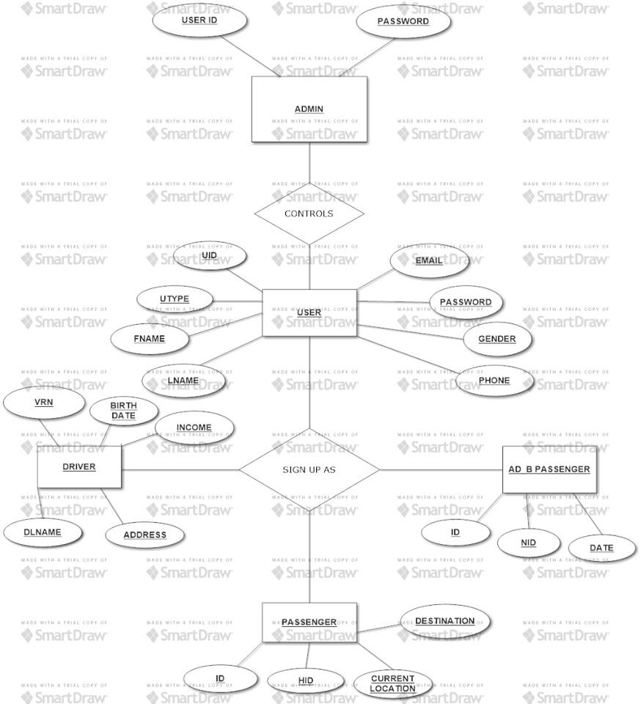

***Schema Diagram***

**User Table**

|  |  |  |  |  |  |  |  |
| --- | --- | --- | --- | --- | --- | --- | --- |
| UID | UType | FName | LName | Email | Password | Gender | Phone |

**Driver**

|  |  |  |  |  |
| --- | --- | --- | --- | --- |
| DName | BirthDate | VRN | Income | Address |

**Passenger**

|  |  |  |  |
| --- | --- | --- | --- |
| ID | HID | CurrentLocation | Destination |

**Ad B Passenger**

|  |  |  |
| --- | --- | --- |
| ID | NID | Date |

***User manuals with snapshots***

**HOMEPAGE**

At the top-left corner there is the menu bar and at the top right corner there is this login and register option.

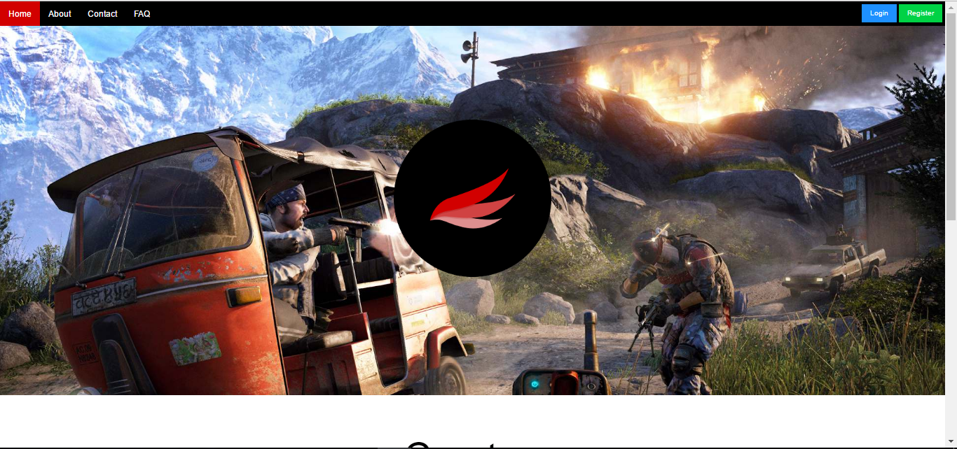

**At the homepage, there is a small description in the bottom about Crypton CNG Management System .**

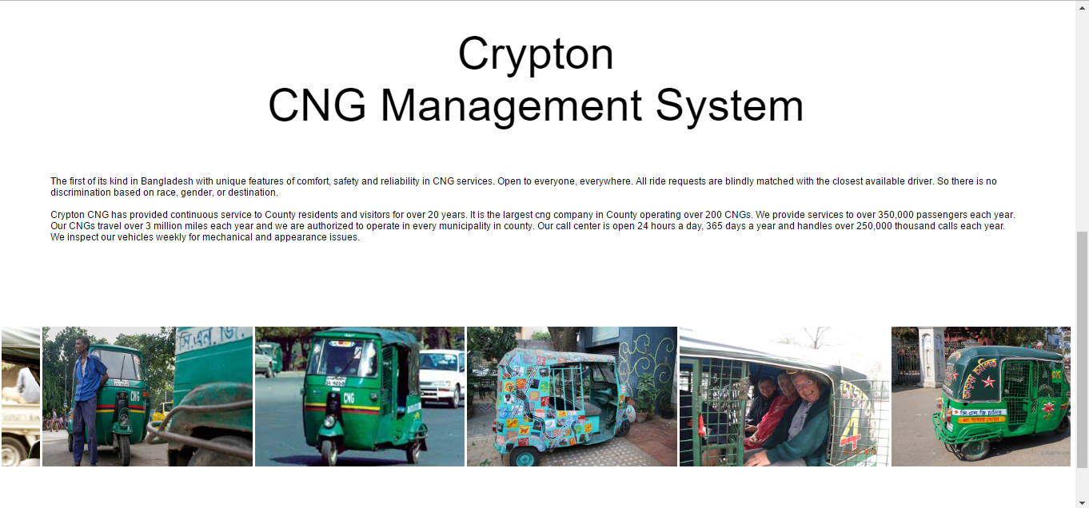

**In the About page there is the complete overview about the Member of the company**

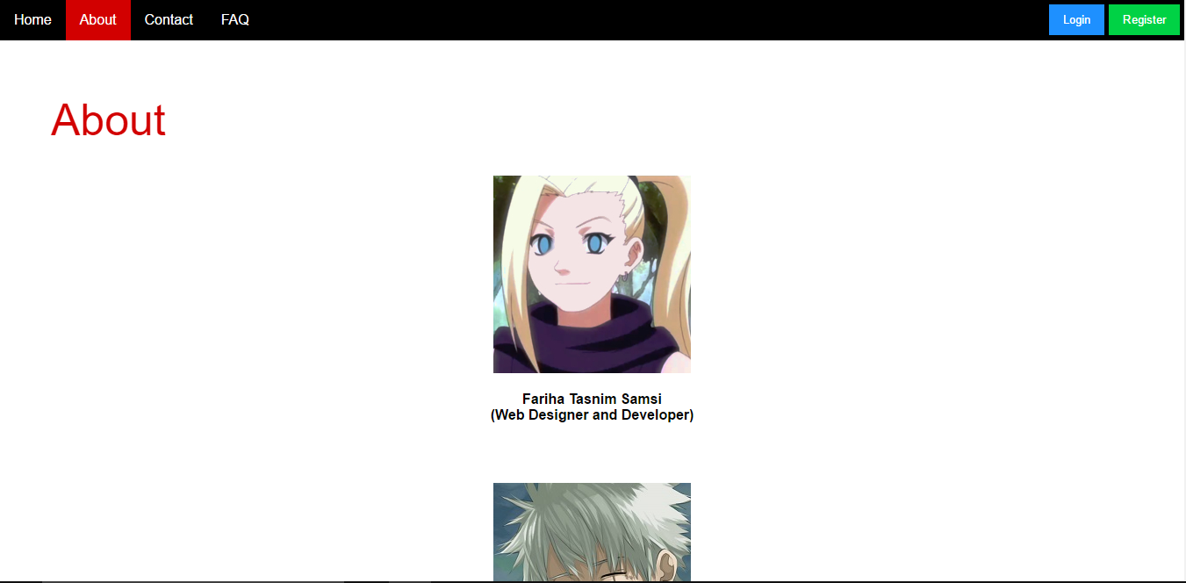

Overview pictures of the varieties of the CNGS is also there.

**In the Contact page :**

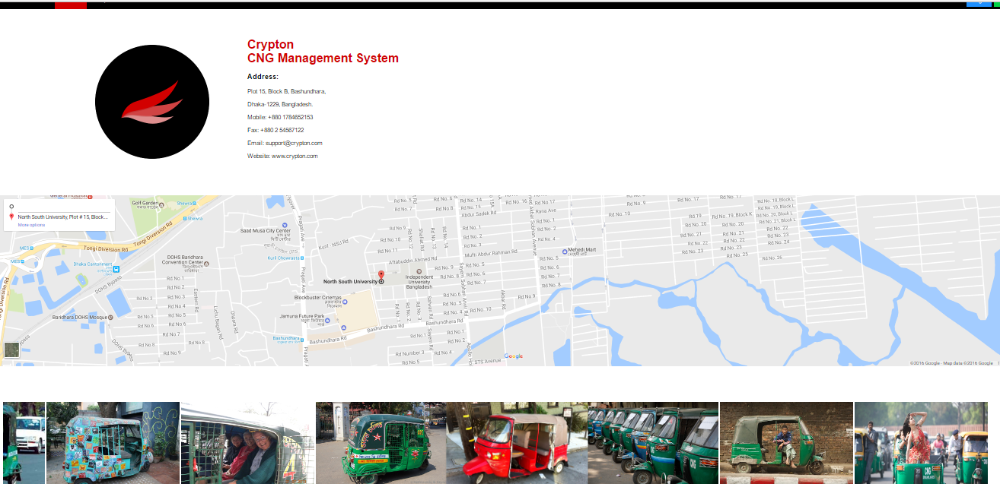

**In the FAQ page :**

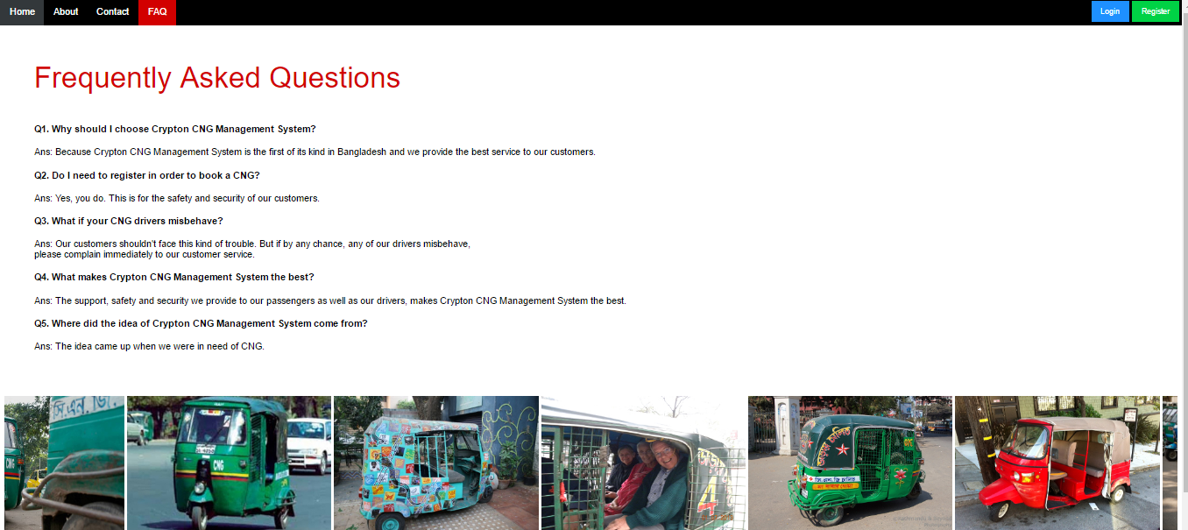

**Some questions and answers related to our CNG Management System has been given there.**

**Register page: As a driver and passenger**

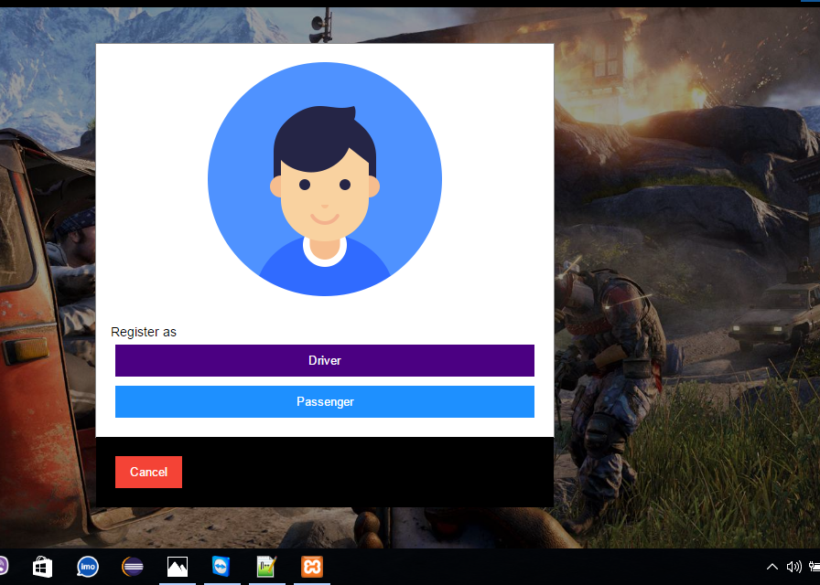

**Sign up page for passenger:**

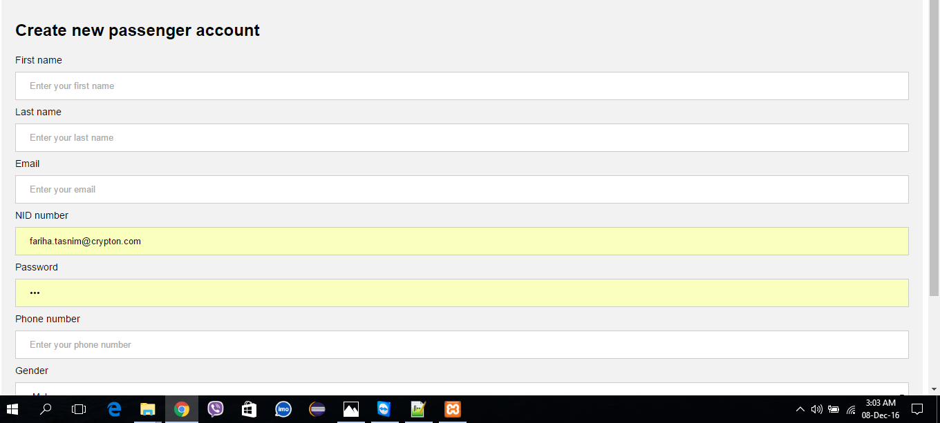

**Sign up page for driver:**

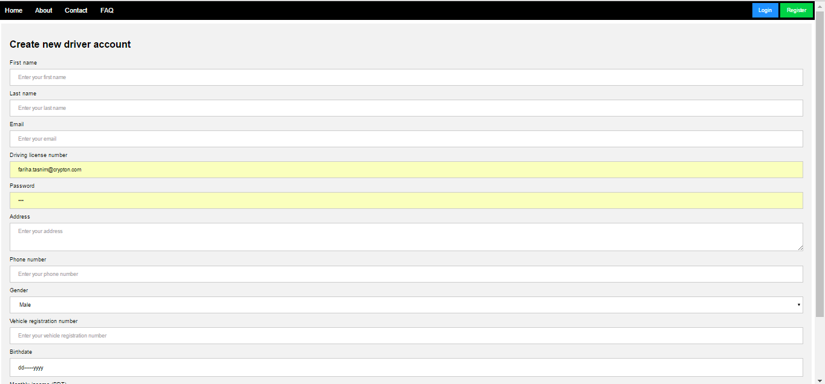

**Login page:Driver of passenger can login within their email and password**

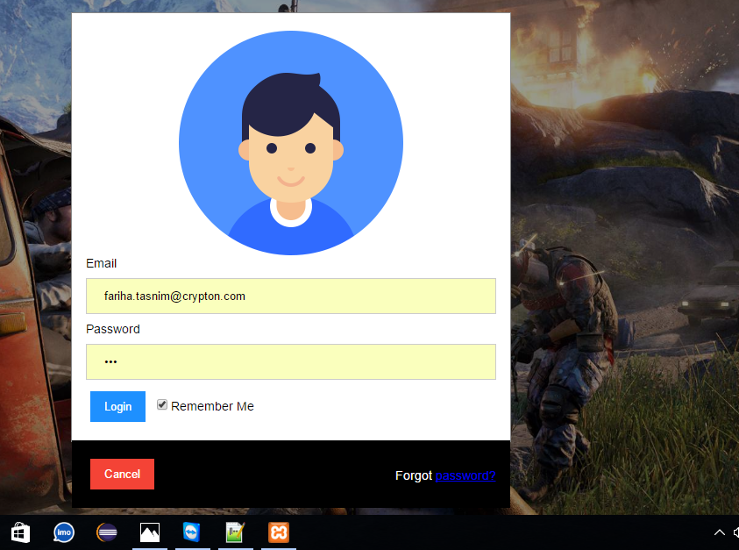

**Passenger profile page:** passenger can book their CNG by using their id

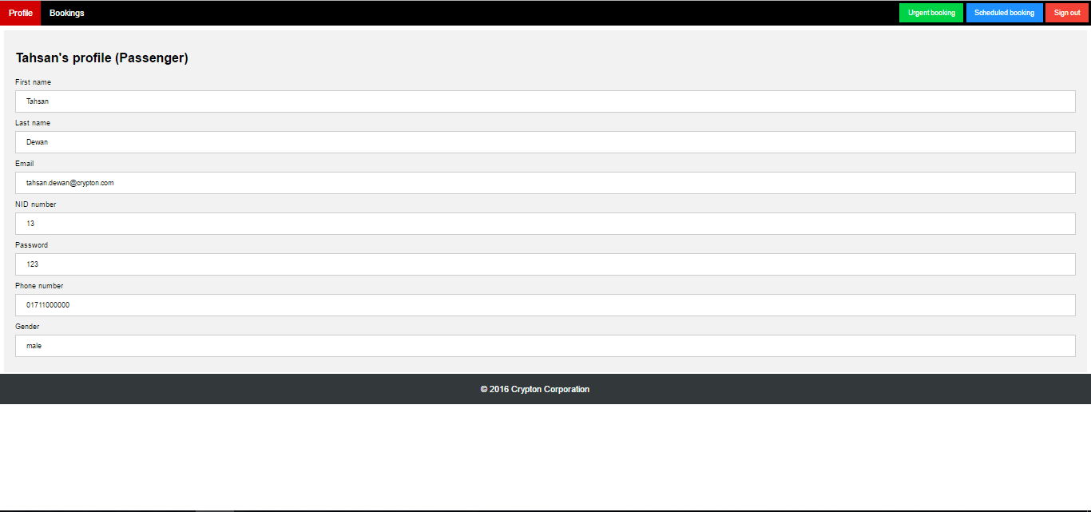

**Booking page:**

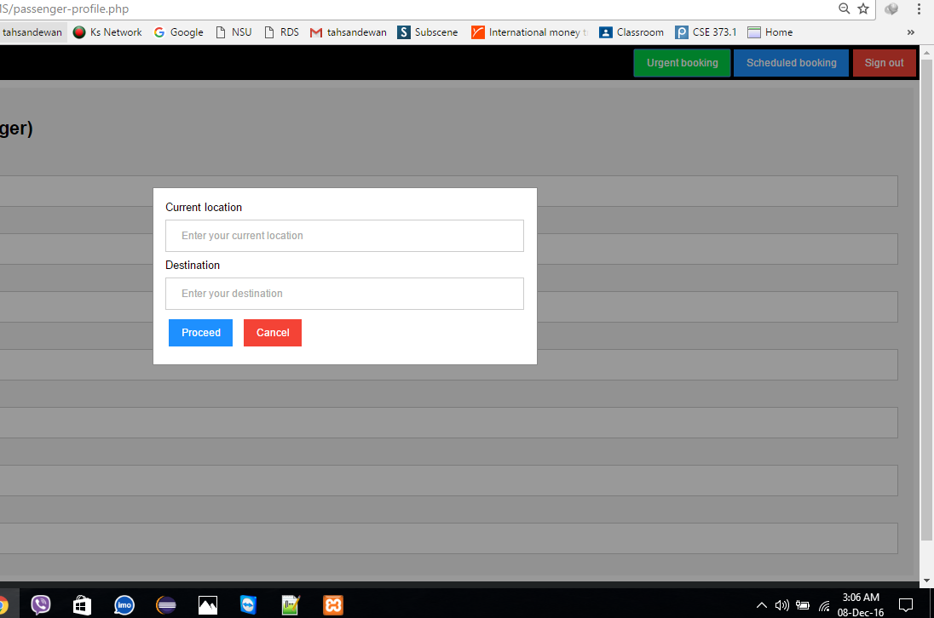

**Booking history page:**

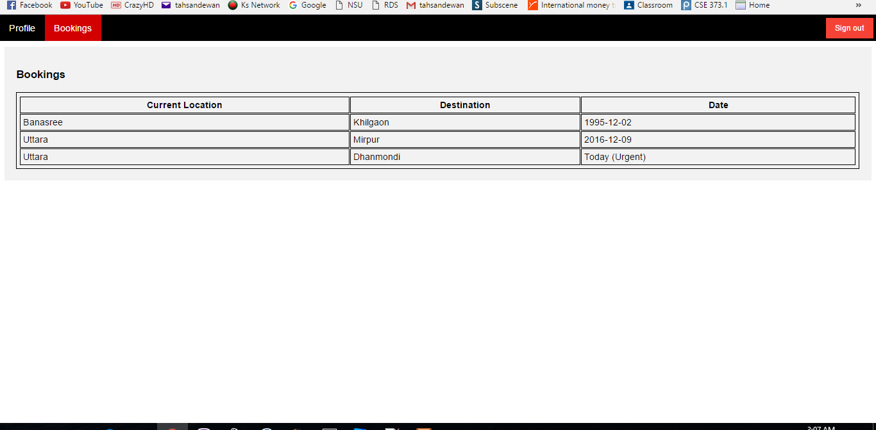

***Codes/Query***

**Some of the queries are given below :**

**Driver registration (insert data**

**=======================**

**1) "INSERT INTO cryptoncngms.users VALUES('$uid', 'driver', '$fname', '$lname', '$email', '$password', '$gender', '$phone')"**

**2) "INSERT INTO cryptoncngms.drivers VALUES('$uid', '$address', '$vrn', '$birthdate', '$income')"**

**Passenger registration (insert data)**

**==========================**

**"INSERT INTO cryptoncngms.users VALUES('$uid', 'passenger', '$fname', '$lname', '$email', '$password', '$gender', '$phone')"**

**Login (retrieve data)**

**================**

**"SELECT uid, utype FROM cryptoncngms.users WHERE email = '$email' and password = '$password'"**

**Admin profile (retrieve data)**

**======================**

**"SELECT * FROM cryptoncngms.users WHERE cryptoncngms.users.uid = '$uid' and cryptoncngms.users.utype = 'admin'"**

**Admin to view driver informations (retrieve data)**

**=====================================**

**"SELECT * FROM cryptoncngms.users, cryptoncngms.drivers WHERE uid = dlnum"**

**Admin to view passenger informations (retrieve data)**

**========================================**

**"SELECT fname, lname, phone, current_location, destination, date FROM cryptoncngms.users, cryptoncngms.passengers, adbpassenger WHERE cryptoncngms.users.uid = cryptoncngms.passengers.nid and cryptoncngms.passengers.id = cryptoncngms.adbpassenger.id"**

**Driver profile (retrieve data)**

**======================**

**"SELECT * FROM cryptoncngms.users, cryptoncngms.drivers WHERE cryptoncngms.users.uid = '$uid' and cryptoncngms.users.uid = cryptoncngms.drivers.dlnum"**

**Driver to see which passengers have booked CNG (retrieve data)**

**=================================================**

**"SELECT fname, lname, phone, current_location, destination, date FROM cryptoncngms.users, cryptoncngms.passengers, adbpassenger WHERE cryptoncngms.users.uid = cryptoncngms.passengers.nid and cryptoncngms.passengers.id = cryptoncngms.adbpassenger.id"**

**Passenger profile (retrieve data)**

**========================**

**"SELECT * FROM cryptoncngms.users WHERE cryptoncngms.users.uid = '$uid' and cryptoncngms.users.utype = 'passenger'"**

**Passenger to see his/her own bookings (retrieve data)**

**========================================**

**"SELECT current_location, destination, date FROM cryptoncngms.passengers, adbpassenger WHERE cryptoncngms.passengers.nid = '$uid' and cryptoncngms.passengers.id = cryptoncngms.adbpassenger.id"**

**Booking (insert data)**

**=====================**

**"INSERT INTO cryptoncngms.passengers VALUES('', '$uid', '$current_location', '$destination')"**

**Urgent**

**======**

**"INSERT INTO cryptoncngms.adbpassenger VALUES('', '$uid', NULL)"**

**Scheduled**

**=========**

**"INSERT INTO cryptoncngms.adbpassenger VALUES('', '$uid', '$date')"**